NAME : RULLA SELFIANA

ID : 410921361

**E Library Management System**

1. **Background**

* **Purpose**

To manage book issued in library by admin and to see the book issue by user

* **Materials**

XAMPP

Visua Studio Code

Web Browser (for phpmyadmin and website)

1. **Method**

* **Requiment Analysis**

Use case

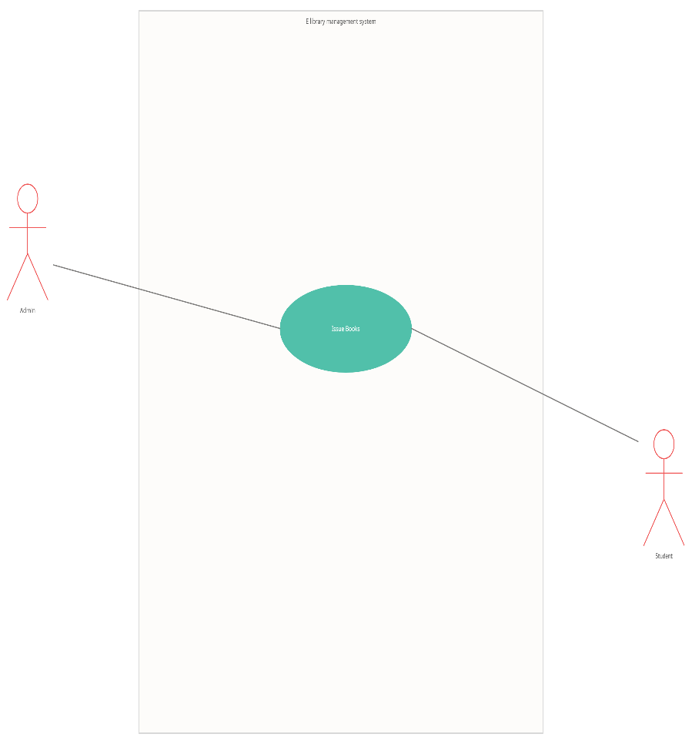

* **Flow chart**

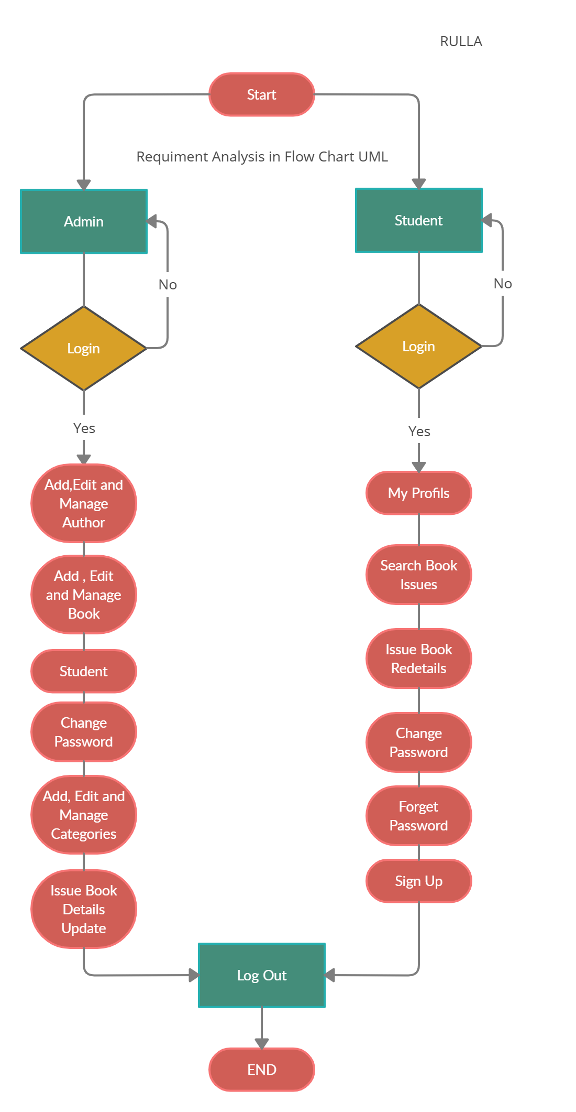

* **ER Diagram**

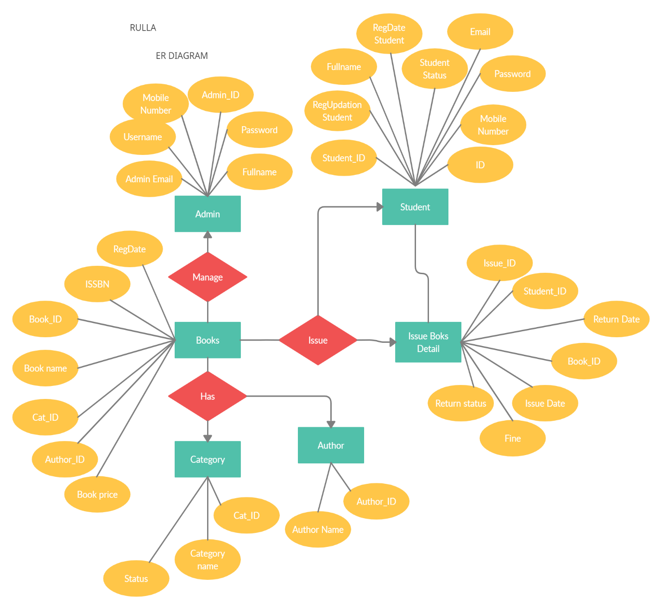

* **Relation Schema**

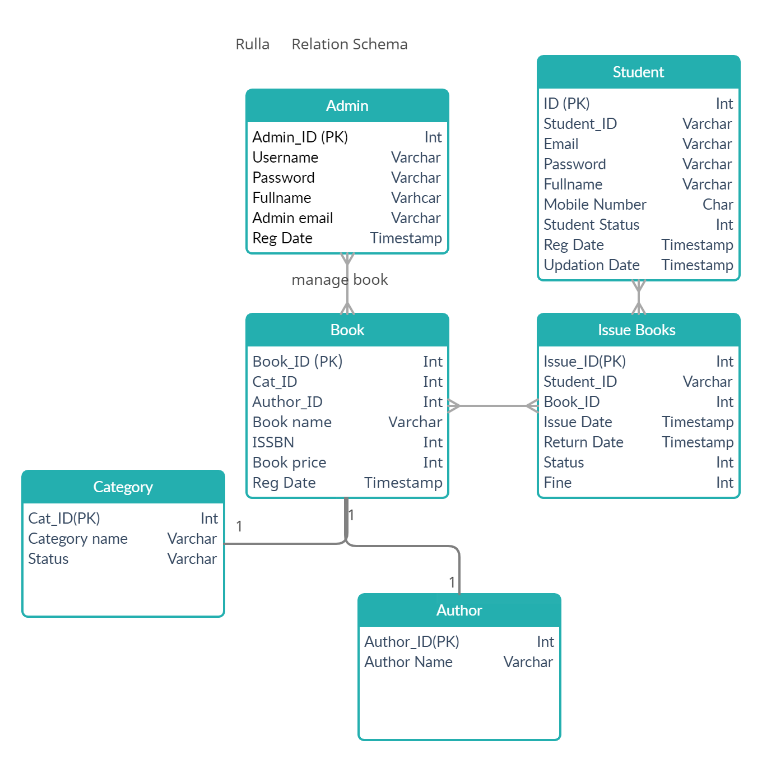

Design Application Protocol

For Admin

Login first and after that the admin can manage anything on library management



For User

The user can sign up first if don’t have account, after that can login and see what the book to borrow and search the book borrowed



1. **Result**

Connection Database

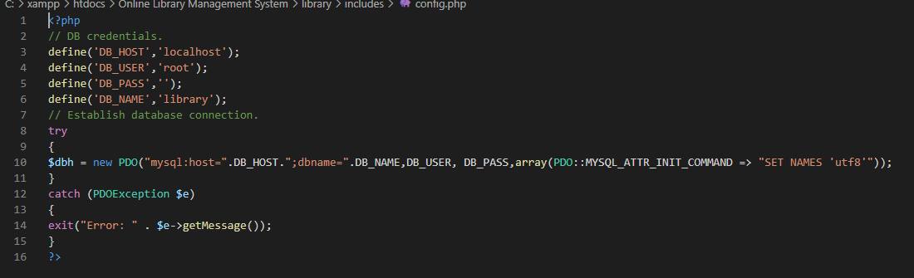

WEB INDEX PAGE

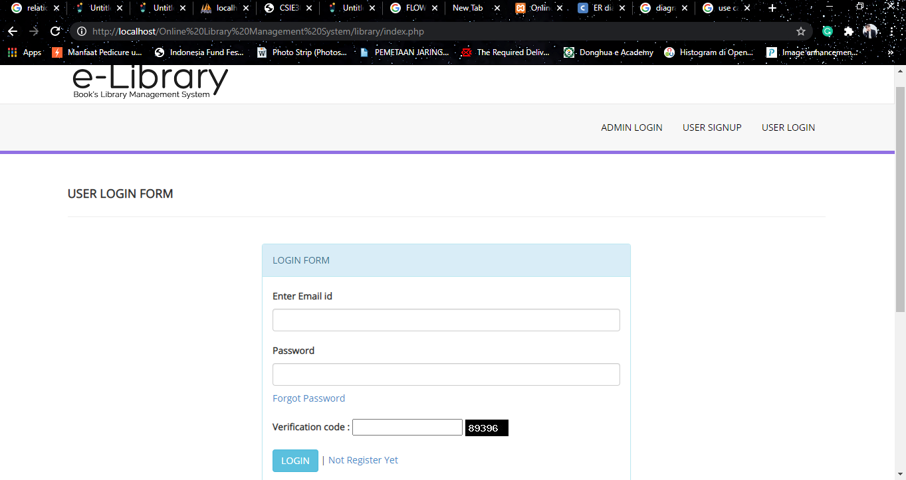

User Sign Up

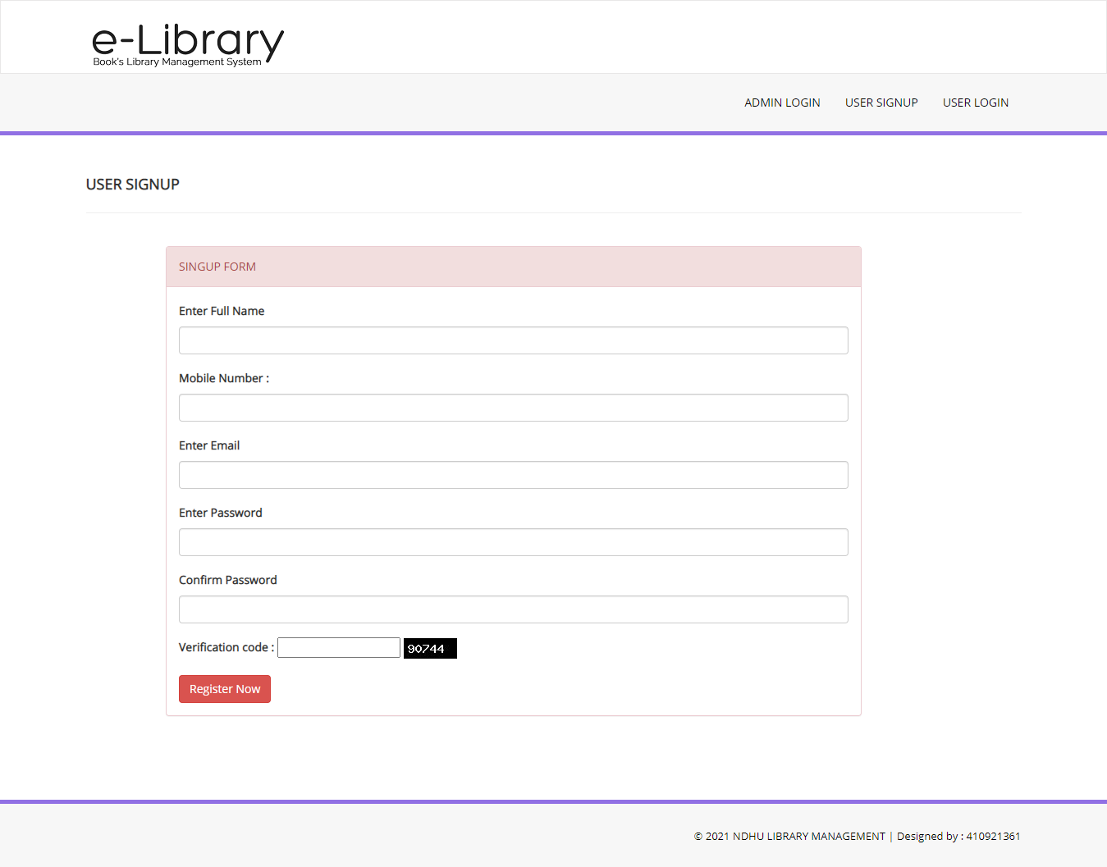

USER PAGE DASHBOARD

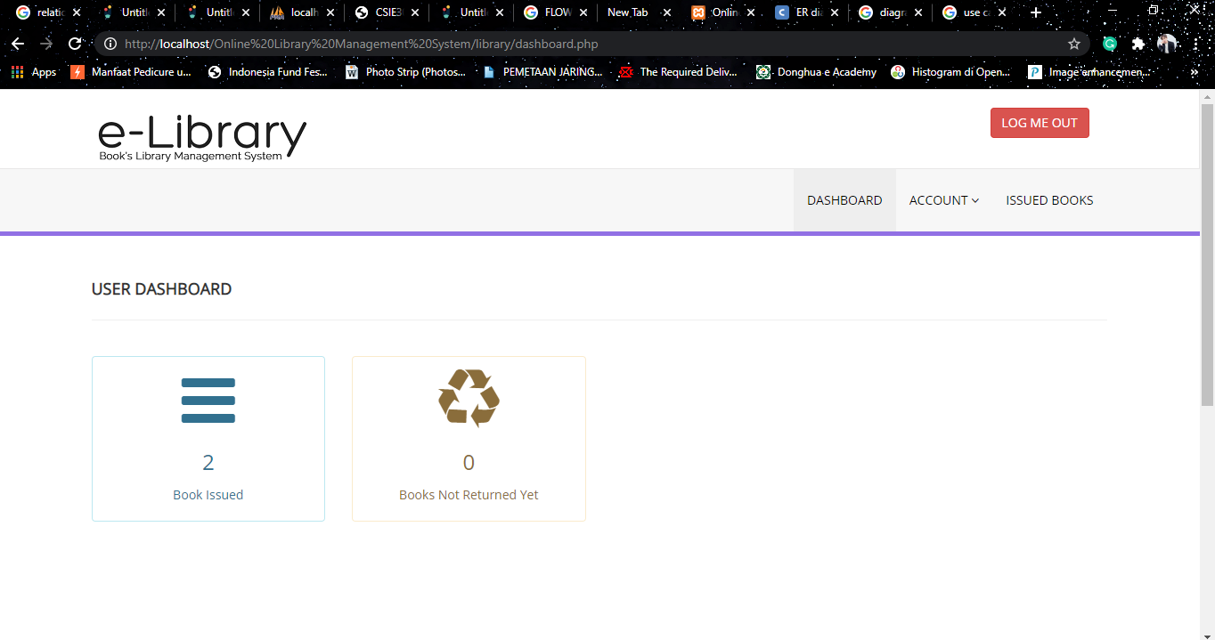

Admin Page Dashboard

